Database design (DDL) and and data import phase

Table 1: customer_behaviour
Column Name Description
customer_id Unique identifier for each customer
Total_orders Total no.of orders
Total_spending Total amount spent
Average_order_value total average orders
Last_order_days latest orders
Churn_flag 1 = Churned (inactive over 90 days or zero orders), 0 = Active
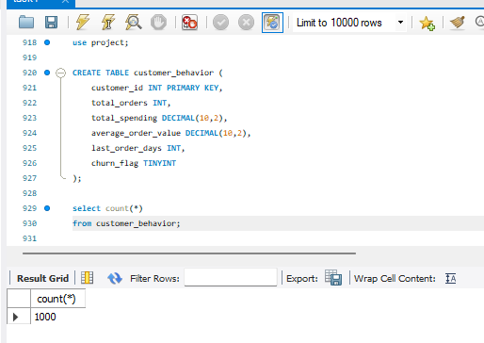

Table 2 : customers
Column Name Description
customer_id Unique identifier for each customer
customer_name Full name of the customer
age Customer age in years
gender Male / Female / Other
city City where the customer is located
signup_date Date the customer registered on the platform
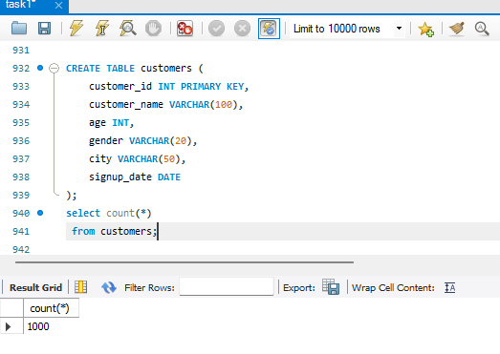

Table 3 : delivery_partners
Column Name Description
partner_id Unique identifier for each delivery partner
partner_name Full name of the delivery partner
vehicle_type Bike / Scooter / Bicycle / Electric Bike
joining_date Date the partner joined the platform

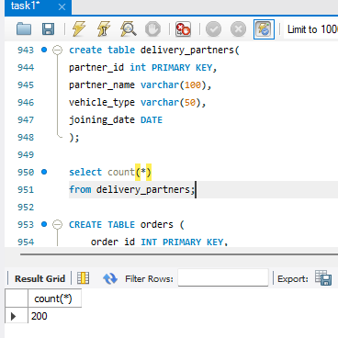

Table 4 : orders
Column Name Description
order_id Unique identifier for each order
customer_id Links to customers table
restaurant_id Links to restaurants table
partner_id Links to delivery_partners table
order_time Timestamp when the order was placed
delivered_time Timestamp when order was delivered (blank if not delivered)
order_amount Value of items ordered in INR
delivery_fee Delivery charge applied to the order
status Delivered / Cancelled / Pending

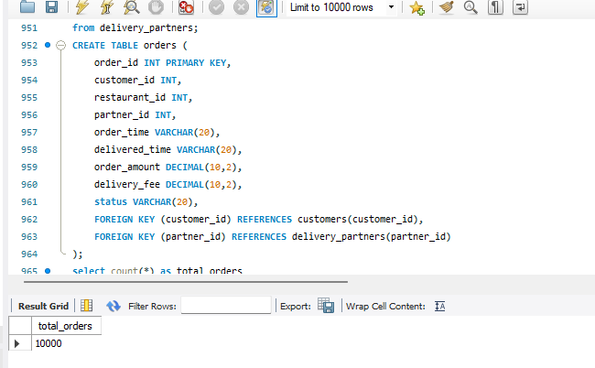

Table 5: payments
Column Name Description
payment_id Unique identifier for each payment
order_id Links to orders table
payment_mode UPI / Credit Card / Debit Card / Cash on Delivery / Wallet
amount Total amount paid including delivery fee in INR
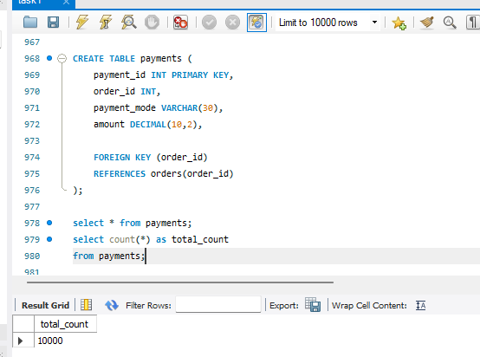

Table 6: ratings
Column Name Description
rating_id Unique identifier for each rating record
order_id Links to orders table
customer_rating Rating given by the customer out of 5.0
feedback Free-text comment written by the customer

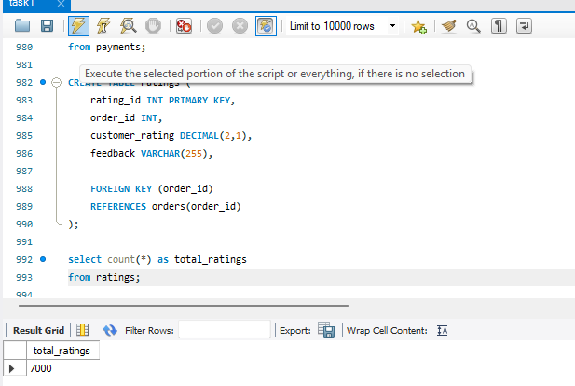
Table 7: restaurants
Column Name Description
restaurant_id Unique identifier for each restaurant
restaurant_name Name of the restaurant
cuisine_type Category of food served
city City where the restaurant operates
rating Platform rating out of 5.0
